## Getting Started Module

The Getting Started module has four **primary** sections (see green arrows below):

**Note:** your instructor may include additional headings and in your class.

* Read and Review
* Download
* Participate
* Complete and Submit

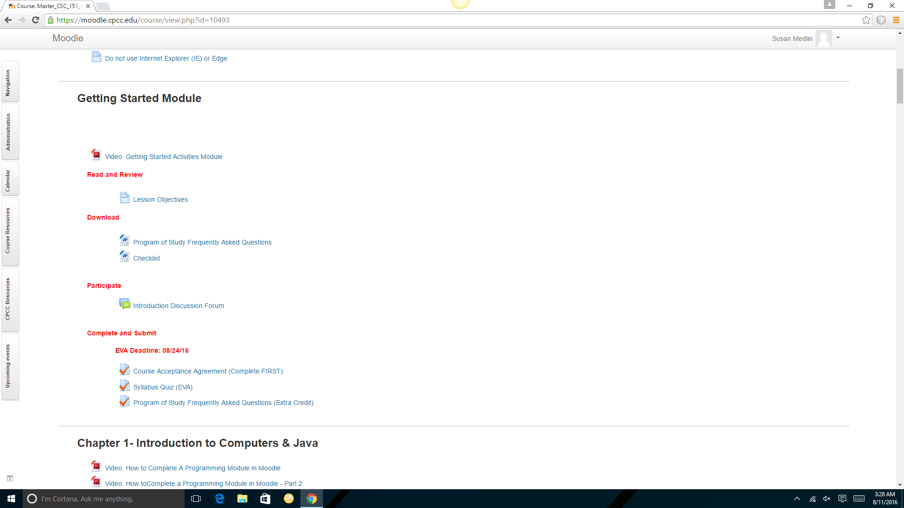

### Read and Review

The Read and Review section will provide the lesson objectives, i.e., learning outcomes, for the week’s activities.

### Download

The Download section will have documents and/or files you should download. Contact your instructor if you need assistance downloading documents and files.

### Participate

The Participate heading will have links to discussion forums and other types of communication tools.

### Complete and Submit

The Complete and Submit heading will have links to activities you should complete. Instructions for how to complete the assignments will be provided under each activity link. Refer to your **Due Date Calendar** to make sure you do not miss important deadlines.